**PHP Procedural Programming**

**Course Description**

The course provides basic and workable knowledge and skillset in programming a web application using PHP. Aside from PHP, the course will tackle briefly database in order to make the web application interactive and database-driven.

In consideration of the constraints on common availability, this program will use free videos on Youtube for lesson input, and have formative assessments in the form of outputs and source code review at pre-determined times. The learner is expected to inform immediately the trainer when s/he has completed the module formative assessments for learning validation and as a prerequisite to receiving the succeeding course module.

**Prerequisite Knowledge**

A participant is expected to have previous working knowledge and appreciation of:

* Programming in another language or at least HTML
* Basic appreciation of database management and database queries

**Prerequisite Equipment**

The learner is expected to have or to be provided a computer that can host the latest version of Apache and MySQL server, PHP, and a code editor (e.g., Visual Studio Code). Installation procedure shall be provided during the first video lesson.

**Program Learning Outcome**

At the end of this course, the participant should be able to develop and upload a database-driven web application using procedural programming with PHP and basic frontend framework.

**Course Contents**

Module 1: Introduction to PHP syntax and basic programming logic

Module 2: Basic interactive web app programming

Additional Learning: Bootstrap, Frontend framework

Module 3: Database-driven web app

Additional Learning: Git and Github for Source Code Management

Module 4: Working with files

Module 5: Integration and Project Presentation

**Module 1: Introduction to PHP Syntax and Basic Programming Logic**

At the end of this module, the learner is expected to efficiently and effectively write code that will run basic logic (conditions and loops) in a PHP file hosted in a local development server.

**Self-paced Learning Estimated Timeline**: 1 week

**Pre-Lesson Reference (Recommended only)**

Download Page of Visual Studio Code: <https://code.visualstudio.com/>

Fixing “PHP Executable Not Found” error

[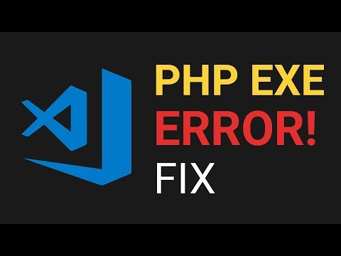](https://www.youtube.com/embed/yEaDrTla9zc?feature=oembed)

Recommended Visual Studio Code Extensions

[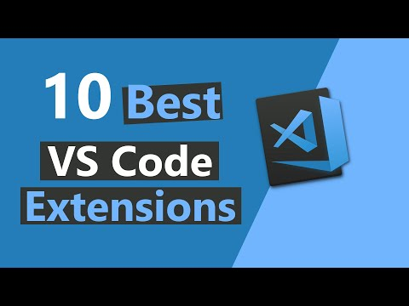](https://www.youtube.com/embed/c5GAS_PMXDs?start=270&feature=oembed)

**Resources**

1. What is PHP, including installation of local development server

[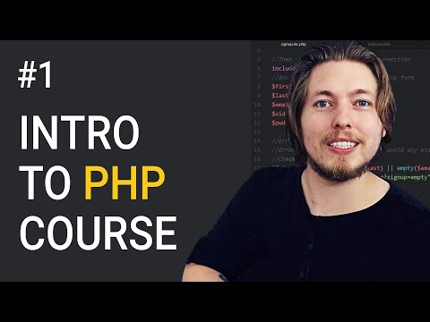](https://www.youtube.com/embed/videoseries?list=PL0eyrZgxdwhxhsuT_QAqfi-NNVAlV4WIP)

1. Basic Syntax

[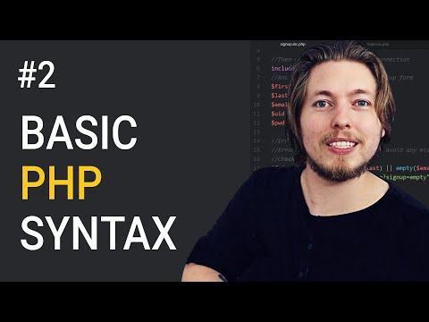](https://www.youtube.com/embed/videoseries?list=PL0eyrZgxdwhxhsuT_QAqfi-NNVAlV4WIP)

1. Scalar Data Types

[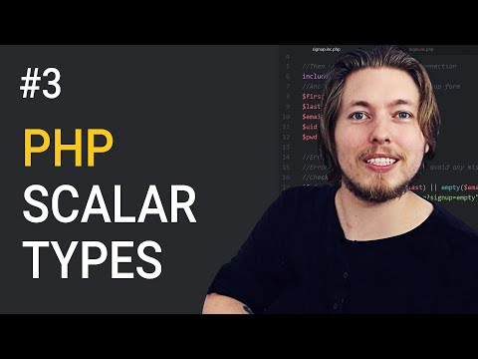](https://www.youtube.com/embed/videoseries?list=PL0eyrZgxdwhxhsuT_QAqfi-NNVAlV4WIP)

1. Variables

[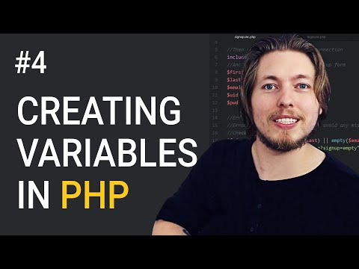](https://www.youtube.com/embed/videoseries?list=PL0eyrZgxdwhxhsuT_QAqfi-NNVAlV4WIP)

1. Expressions

[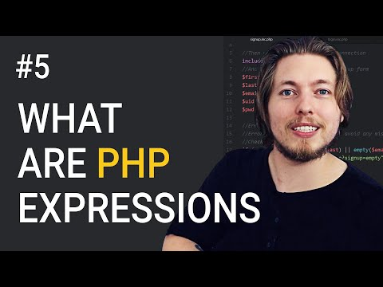](https://www.youtube.com/embed/videoseries?list=PL0eyrZgxdwhxhsuT_QAqfi-NNVAlV4WIP)

1. Operators

[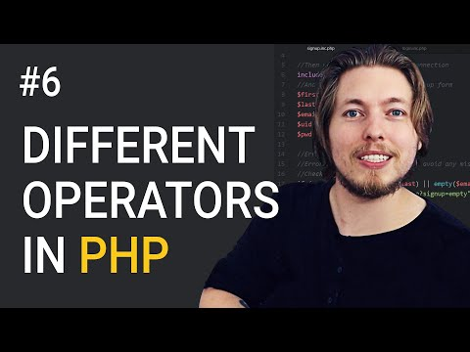](https://www.youtube.com/embed/videoseries?list=PL0eyrZgxdwhxhsuT_QAqfi-NNVAlV4WIP)

1. Control Structures

[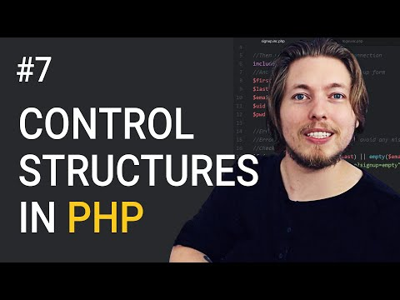](https://www.youtube.com/embed/videoseries?list=PL0eyrZgxdwhxhsuT_QAqfi-NNVAlV4WIP)

1. Conditional Statements

[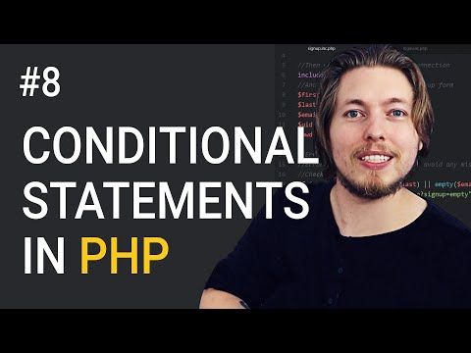](https://www.youtube.com/embed/videoseries?list=PL0eyrZgxdwhxhsuT_QAqfi-NNVAlV4WIP)

1. Loops

[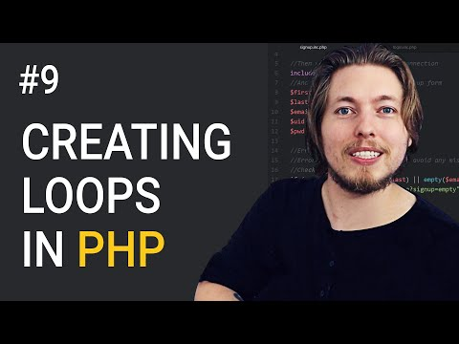](https://www.youtube.com/embed/videoseries?list=PL0eyrZgxdwhxhsuT_QAqfi-NNVAlV4WIP)

1. Break and Continue

[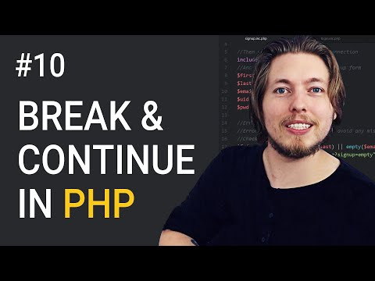](https://www.youtube.com/embed/videoseries?list=PL0eyrZgxdwhxhsuT_QAqfi-NNVAlV4WIP)

**Module Exercise**

* Conditional Statement: Create file **exercise1.php**. Write a code with variable $energysource that will display $type based on the following table:

|  |  |
| --- | --- |
| **Energy Source** | **Type** |
| Coal | Fossil |
| Oil | Fossil |
| Natural Gas | Fossil |
| Hydro | Renewable |
| Geothermal | Renewable |
| Solar | Renewable |
| Wind | Renewable |
| Biomass | Renewable |
| Nuclear | Renewable |
| Ocean | Renewable |

To test the validity of the code, the trainer will check your code and ask you to write the type of energy source from the column Energy Source as the value of the variable $energysource. The output in the browser should be the corresponding value from the column Type.

* Loops: Create file **exercise2.php**. Write code that will output in the browser numbers 5 listing down to a number from variable $x. The value of $x will be determined by the trainer during code checking. You may set an initial value for $x but the new value to be given by the trainer should reflect the new list in the browser when refreshed.